**Experiment No: 05**

Aim: Implementation of Replication transparency in DDB.

Labwork:

**Theory:** Replication is actually quite straightforward. At its core, it merely involves an administrator picking a server to act as the master, and then registering one or more slave servers to receive updates from the master. Each slave server is responsible for contacting the master server. This master server records all data manipulation statements in a binary log, which is then fed in a stream to any slave(s) that contact the master. The slave computers then play back these statements locally, thus updating their own data copies accordingly. In addition, a slave can, in turn, act as a master to other servers. This lets you construct sophisticated chains of replication servers.  
Obviously, there are many steps to follow to correctly configure and use replication, but the preceding discussion describes it accurately at a high level.  
  
**BENEFITS OF REPLICATION:**  
Replication is recommended if any of the following are met:  
1. high availability--the data stored on your MySQL server needs to be accessible 24 x 7  
2. Frequent backups--to protect against data loss, you often back up your databases.  
3. Mixed processing profiles--your MySQL database server must field requests from online transaction process (OLTP) and decision support system (DSS) users.  
4. Abundant, low-performance computers--your organization might not have the fastest computers, but they have lots of them.  
5. Widely dispersed users--your MySQL users are spread among multiple locations.  
6. Modular application code--your MySQL-based applications can be easily altered to read data from the slave servers while writing data to the master.

**Implementation:**

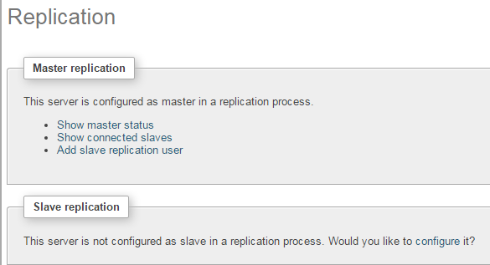

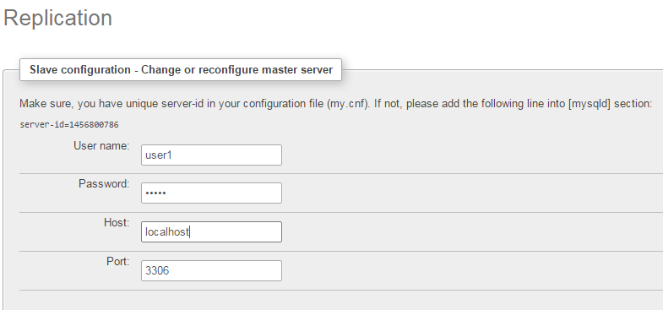

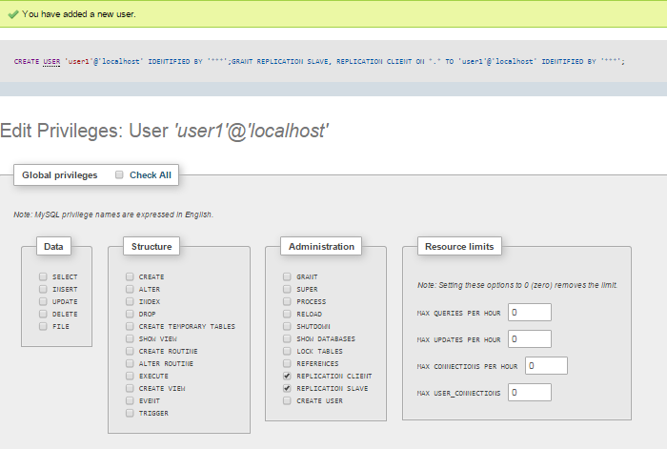

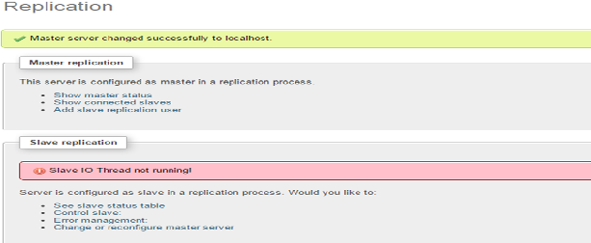

**Conclusion**: Replication transparency ensures that replication of databases are hidden from the users. It enables users to query upon a table as if only a single copy of the table exists.In case of failure of a site, the user can still proceed with his queries using replicated copies without any knowledge of failure which is why it has many real life applications.